**Session-3 Assignment**

**Name:- Aryan Dilipbhai Langhanoja**

**Enroll No:- 92200133030**

**AIM**: To plot VI characteristics of PN junction diode.

**Objective:**

1. To understand PN junction, Barrier potential, Cut-in voltage, Current flow in Forward and Reverse bias (silicon and germanium) PN diode.
2. To analyze the current flow in forward and reverse bias conditions.
3. To analyze static and dynamic impedances in forward and reverse bias.
4. To understand ideal model, simplified model and piecewise linear model for analysis purpose.

**Outcome:** Students will be able to,

1. Identify diode with anode and cathode terminals and learn the connections for forward bias and reverse bias condition.
2. Measure the voltage across diode and current through diode.
3. Develop the I-V Characteristics of diode.
4. Appreciate the importance of resistance of diode in forward bias and reverse bias condition.

**Components and Apparatus:**

1. Diode 1N4007
2. 100Ω Resistor
3. DC power Supply
4. Multimeters

**Task-1** Tabulate V-I values for PN diode (Forward Bias and Reverse Bias) (simulate in Multi-sim)Circuit Schematic:

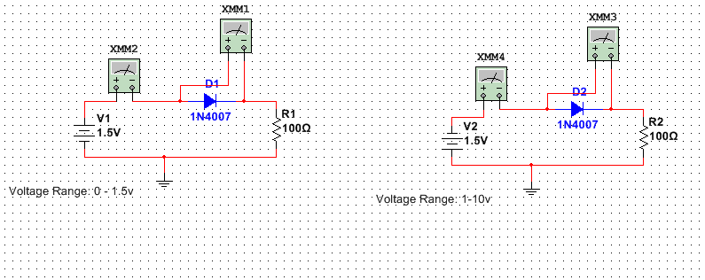

**Observation Table:**

Forward Bias:

|  |  |  |
| --- | --- | --- |
| **Supply Voltage**  **Vs (Volts)** | **Diode Forward Voltage Drop**  **Vd (Volts)** | **Diode Forward Current**  **Id (mili-ampere)** |
| 0 | 0 V | 0 mA |
| 0.1 | 0.099 V | 0.000189 mA |
| 0.2 | 0.199 V | 0.00149 mA |
| 0.3 | 0.298 V | 0.01 mA |
| 0.4 | 0.393 V | 0.064 mA |
| 0.5 | 0.471 V | 0.288 mA |
| 0.6 | 0.522 V | 0.776 mA |
| 0.7 | 0.554 V | 1.452 mA |
| 0.8 | 0.576 V | 2.23 mA |
| 0.9 | 0.593 V | 3.065 mA |
| 1.0 | 0.606 V | 3.936 mA |
| 1.1 | 0.617 V | 4.829 mA |
| 1.2 | 0.626 V | 5.740 mA |
| 1.3 | 0.633 V | 6.662 mA |
| 1.4 | 0.640 V | 7.594 mA |
| 1.5 | 0.646 V | 8.533 mA |

Reverse Bias:

|  |  |  |
| --- | --- | --- |
| **Supply Voltage**  **Vs (Volts)** | **Diode Reverse Voltage Drop**  **Vd (Volts)** | **Diode Reverse Saturation Current**  **Is (micro-ampere)** |
| 0 | 0 V | 0 µA |
| 1 | -0.999 V | -0.032 µA |
| 2 | -2 V | -0.033 µA |
| 3 | -3 V | -0.034 µA |
| 4 | -4 V | -0.035 µA |
| 5 | -5 V | -0.036 µA |
| 6 | -6 V | -0.037 µA |
| 7 | -7 V | -0.038 µA |
| 8 | -8 V | -0.039 µA |
| 9 | -9 V | -0.04 µA |
| 10 | -10 V | -0.042 µA |

**Task-2** Plot VI Characteristics (from the table): (Plot using MS-excel or Libre)

**Task-3** For the above VI characteristic draw the piece-wise linear model.

**Task-4** Calculate Static and Dynamic Resistance: (From readings of VI characteristics)

DC or Static Resistance: $R_{D}= \frac{V_{D}}{I_{D}}$

|  |  |  |
| --- | --- | --- |
| **Diode Forward Voltage Drop**  **Vd (Volts)** | **Diode Forward Current**  **Id (mili-ampere)** | **Static Resistance**  **RD**  **Ohms** |
| 0.2 | 0 | Infinite |
| 0.4 | 0.064 mA | 6.25 kΩ |
| 0.7 | 8.533 mA | 0.082 kΩ |

AC or Dynamic Resistance: $r_{d}= \frac{{∆V}_{D}}{∆I_{D}}$

|  |  |  |
| --- | --- | --- |
| **Diode Forward Voltage Drop**  **∆Vd (Volts)** | **Diode Forward Current**  **∆ Id (mili-ampere)** | **Dynamic Resistance**  **rd**  **Ohms** |
| 0.2 – 0.4 |  |  |
| 0.4 – 0.7 |  |  |

In This Circuit , DC Source Is Connected . Therefore Dynamic Resistance or AC resistance will be 0.

**Task 5**: Find the cut in voltage in forward bias diode using graph. Kindly refer following diagram for more details about cut-in-voltage.

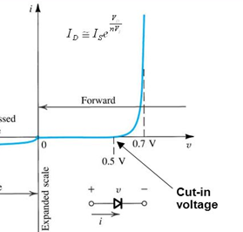

* The Forward Voltage at Which the current through

The junction start increasing rapidly, is called the knee voltage or cut-in voltage.

* Connect a Battery to the diode with a resistor. Connect an ammeter. Slowly increase the battery voltage.
* As you come close to the cut-in voltage,the ammeter will start moving. i.e current is flowing through the diode.
* At this stage connected a Multimeter/Voltmeter across the diode and observe the reading.
* In the above Graph, We Can See That at 0.5V Current start Rising. And According the definition **0.5V** is Our Cut-in Voltage.

**Conclusion:-** When Diode Connected In The Circuit The Current Is Not Increasing Linear.

After The Cut-in voltage Is Croosed The current Start Rising. And One certain Amount Of Voltage Drop Is done across diode When Barrier Potential Reached. Before Cut-off voltage, Current in voltage is very low. Because Of Diode Current Is Able to flow in only one direction.